Historical Trauma: Past Pains Must Lead to Future Promise[1]
By Karsonya Wise Whitehead

As someone who grew up in Jim Crow South Carolina, my father likes to call himself a survivor. He has looked white supremacy and racial hatred in the eye, and though he has not won, he wants to note that he has not lost, not yet. When I was in college, I asked him why he was convinced that he had not won. He said that winning, for Black folks, would only come when we could walk anywhere in this country, and not be concerned that the color of our skin could mean the end of our life. My father remembers the days when they called him boy even though he was a man, of being dismissed and overlooked even when he followed the rules, and of hearing his mother cry when she realized that he had decided to fight back and not give way. Those types of decisions, he would say, are best made once you realize that you are willing to die to be free rather than live in fear under the thumb of whiteness. My father's family carried pistols and shotguns whenever they rode into town. My grandfather used to sit on a pillow, and his pistol would be underneath, on the right side, in case he needed to grab it in a hurry. His sons, my father's brothers, would have shotguns on the floor near their feet. Nobody ever said it, but everybody knew that if the Klan confronted them, they were prepared to meet their Maker, standing up and fighting back. Such was the reality of living in a Southern County where performative whiteness manifested itself through the law and daily acts of random domestic terror against Black people.
It was not unusual for Black women to have a kaffeeklatsch, sharing horrific tales of lynchings and cross burnings over sweet potato pie and integrated coffee. It was not uncommon for Black households to keep an open Bible on the coffee table and a loaded shotgun at the door. My grandmother, my father’s mother, knew how to shoot. She knew how to steady her shoulder and set her arm so that her hands never wavered. She grew up on a farm, way down South, so she knew how to pick cotton, twist off a chicken's head, and grab her shotgun, look white terror in the eye, and not look away. My father once told me that he learned that the best time to plant a tree was 50 years ago, and his mother taught him that the best time to decide to fight against whiteness was five minutes before the Klan showed up. Such decisions, he would say, must be made before you see the white sheets out your front window.
My father was 12 years old when they murdered Emmett Till in Money, Mississippi. He remembers how his mother and all of the women at the church were weeping and wailing during Sunday church service. What kind of men, the pastor intoned, could look a boy in the eye and then torture him to death? How much effort would it take for us to love the hell out of white people's hearts and minds? My dad said the murder of Emmett Till changed everything. After that, Black boys were taught by their parents, who wanted to keep them alive, not to look white women in the eye, not to speak first, and not to be too excited once you spoke. It was the act of bearing witness to his friends learning how to give way that strengthened my father's resolve to fight. If I was going to die at the hands of whiteness, he told me, I was prepared to do it standing up, with my shotgun in my hand, and a steely resolve in my eye. The summer before they heard about Emmett Till, my father said my grandmother used to sing a song around the house when she was cleaning up. He said she kept her voice real low, but sometimes when she thought she was alone, she would sing loud enough to catch the words: Black bodies swinging in the Southern breeze, Strange fruit hanging from the poplar trees. He said those were the days when she would ask his father to check the shotgun, and she would then tell the kids not to leave the front yard. Black boys, my father would say, should be able to roam free, explore and see the world, walk along with their friends, and dream aloud. We can never say that we have defeated whiteness until this can happen.
In 2020, amid the worldwide protests for justice for Ahmaud Arbery, Breonna Taylor, George Floyd, and Rayshard Brooks, I called my father. We sat in silence, for a long time, on the phone. I told him that I did not know how to move forward and let my sons, his grandsons, fight for Black Lives and against whiteness during a global pandemic. I felt stuck. He said that the moment to make that decision had already come and gone because the best time to decide to fight against whiteness is five minutes before the Klan arrives and not five minutes after they get there. I have been thinking a lot about my father, his life, his words of wisdom, and his decision to fight. He raised me to be a fighter. He taught me to speak first, look folks in the eye, and be myself when I do it. I am the tree that he planted all those years ago. Before he hung up the phone, he said that the second-best time to fight against whiteness was right now. We fight back, he said right before he hung up, because this is how we survive and how we grow.
In 1865, with the ratification of the 13th Amendment, there was a push to provide some form of reparations: 40 acres, a mule, and 50 dollars. I am sure that there was some excitement and a whole lot of trepidation because after seeing the evilness of white people up close, formerly enslaved people probably understood that power never concedes without a battle plan to attack. Six days after the ratification, secret white societies, including the Ku Klux Klan and the White Brotherhood, were founded to restore white order and rule back to the South. They were trying to break us, to scare us into submission. They terrorized us; burned crosses on our property; kidnapped, raped, beat, and lynched us. They were brutal in their efficiency, holding cookouts with their wives and children, while Black bodies, a strange and bitter crop, were hanging from the trees. Southern trees bare strange fruit. The best time to fight is five minutes before the Klan arrives and the second-best time is right now.
Notes:
[1] Portions of this article were printed in Conversations With Dr. Kaye, Afro American newspaper. https://afro.com/author/drkwhitehead/

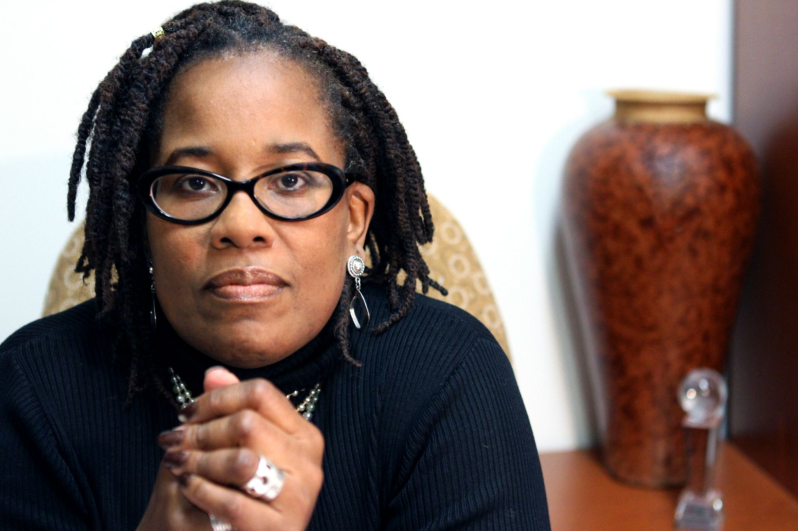
Dr. Karsonya Wise Whitehead, Ph.D., (todaywithdrkaye@gmail.com; Twitter: @kayewhitehead) is the Founding Executive Director of The Karson Institute for Race, Peace, & Social Justice at Loyola University Maryland and the 2021 Edward R. Murrow Regional Award-winning radio host of “Today With Dr. Kaye” on WEAA 88.9 FM. She is the past national secretary of ASALH and the author of five books.

LESSON PLAN
Emmett Till and America’s Trauma
By Tracy Kent

Grades 5-8, Social Science
Overview: It is now 2022, and incidents of hate are occurring daily in our schools, and more and more students are coming to school with various problems that reach far beyond the scope of academics. It is up to us to take a collaborative approach in dealing with these challenges, especially those related to racism, bias, and discrimination. The death of Emmett Till was traumatic then, and this traumatic experience along with other lynching’s around the U.S. during this era have had lasting negative effects on the people of our nation.
Scope and Sequence: This lesson is designed for upper elementary/middle school teachers, for their students, who are on a journey of self-discovery. Teachers will facilitate students’ learning by valuing differences and celebrating the uniqueness of all cultures. Equity and diversity must be part of all of our core values. Many parts of the U.S. were not a safe and welcoming place for African Americans then, and for many, it still isn’t. It is important that we explore this time in history with students, so that we may work towards making all students feel safe and welcome here.
EDUCATION STANDARDS[1]
CCSS.ELA-LITERACY.CCRA.SL.1
CCSS.ELA-LITERACY.CCRA.SL.3
CCSS.ELA-LITERACY.CCRA.SL.4
CCSS.ELA-LITERACY.CCRA.SL.6
OBJECTIVES
1. Students will self-reflect with the purpose of strengthening their self-identity.
2. Students will recognize that perspectives about historical events might look different to others, based on their identities.
3. Students will familiarize themselves with the history of race and laws in the south in the 1950s.
4. Students will use writing as a way of offering and supporting opinions, demonstrating understanding of the subjects they are studying, and conveying real and imagined experiences and events.
5. Students will write to communicate clearly to an external, sometimes unfamiliar audience, and begin to adapt the form and content of their writing to accomplish a particular task and purpose.
MATERIALS NEEDED/SUGGESTED
Lyric sheet/questions for Bob Dylan’s song, “The Death of Emmett Till”[2]
Lyrics Worksheet: Emmett Till Song.docx
Various Images of Emmett Till (use your discretion)
Firsthand accounts about the death of Emmett Till:
- Emmett Till (Documentary) Black History Month (Educational Videos for Students)[3]
- Emmett Louis Till video (High School student submits video for an assignment)[4]
- Aug. 28, 1955 - Emmett Till, Age 14, Abducted and Murdered (Editorial on the death of Emmett Till : Moments in Civil Rights History with D’Army Bailey, collaboration of Comcast/NBC Universal and The Equal Justice Initiative at www.eji.org)[5]
VERIFICATION
1. Students should be able to answer questions about the song, regarding the point of view
of the author, author’s purpose, mood, metaphor (analyzing text), elements of poetry, and impact on the listener.
2. Students should share at least two points connecting the past to the present.
3. Students should compose a short paragraph which communicates a call to action.
ACTIVITY
After they receive the lyrics, play the song The Death of Emmett Till by Bob Dylan and then discuss. (Talk about how songs sometimes read like a story, but don’t follow the rules for writing, like with capitalization and punctuation).
Vocabulary: lynching, racism, segregation, privilege, Jim Crow, Ku Klux Klan, jury, mockery, tragedy, shackles
Show the video clip. Talk about which parts from this clip were not used in the song.
Emmett Till (Documentary) Black History Month (Educational Videos for Students)[6]
CONNECTION
Have the students pick one line from the song that they think is the most impactful and analyze it closely. Ask them: Why did they choose that line? Where do we go from here?
Additional Resource: Article by UK journalist compares Emmett Till to Trayvon Martin, calls Trayvon “The New Emmett Till”[7]
Teacher Resources:
[1] www.corestandards.org/ELA-Literacy/CCRA/SL/1/
[2] The Lyrics of Emmett Till, https://onedrive.live.com/view.aspx?resid=E44A92D6F71E1857!174&ithint=file%2cdocx&wdLOR=c967718C8-0C0C-AD43-89D9-FDB9B233B421&authkey=!AFihDV8RMTVB7kw
[3] https://www.youtube.com/watch?v=8ojlufrQj2w
[4] https://www.youtube.com/watch?v=P6DVqPNB5hw
[5] https://www.youtube.com/watch?v=SYiI7j6GW68
[6] https://www.youtube.com/watch?v=8ojlufrQj2w
[7] https://www.dailymail.co.uk/news/article-2362854/Trayvon-Martin--new-Emmett-Till--The-unarmed-American-teenager-race-icon.html

Tracy Kent is a fifth-grade teacher, currently working in a Title I public school in Horry County, South Carolina. As a 30-year veteran/retiree of the Maryland public school system, she is an accomplished County Curriculum Writer and Elementary Educator who enjoys using her skills to contribute to the advancement of the public school system as a consultant for the Karson Institute of Race, Peace, and Social Justice. She graduated from Johns Hopkins University with a master’s degree in Special Education and represented her county in Maryland as an Equity Liaison for four years.

